How use CLC raster files in QGIS

Step 1) Open dialog for adding a new raster layer (Layer/Add layer/Add raster layer)

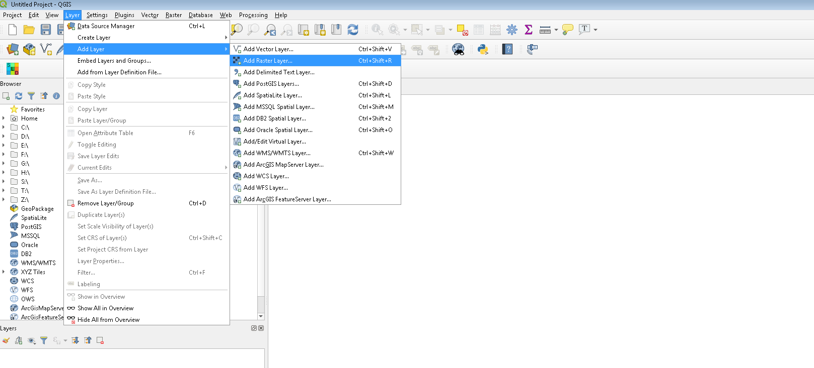

Step 2) In the Add vector layer dialog select
- File option in the Source type part of the dialog
- Browse source tiff raster and click Add
- Click Close
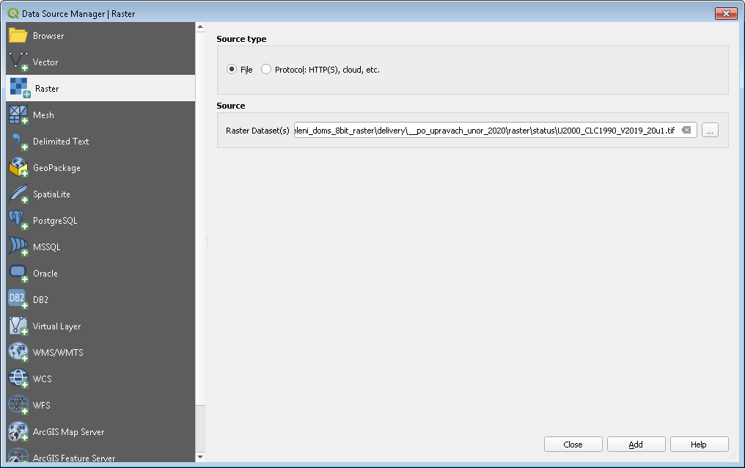

Raster layer is added to the list of layers and to map window. Raster layer is gray now

Step 3) Double click to the layer name - layer properties window will be open

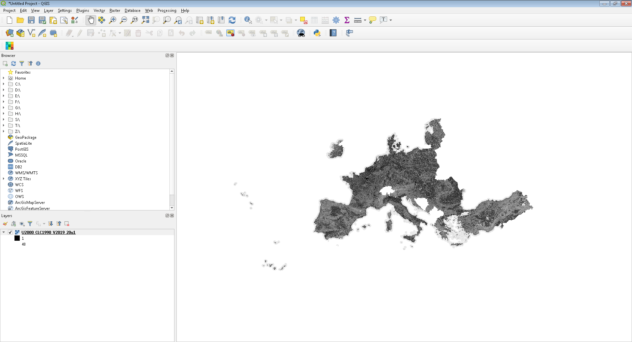
Double click here

Step 4) Select Symbology bookmark and click to Style button

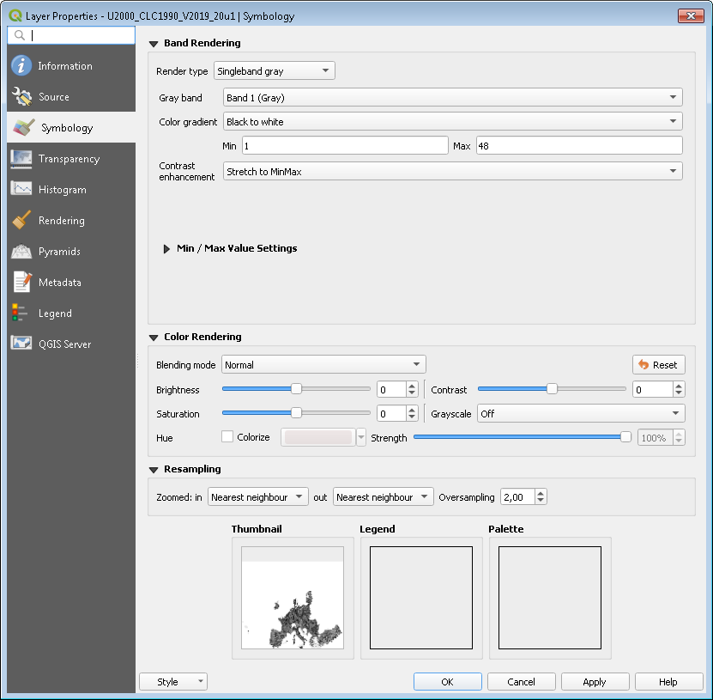
Step 5) Select Load Style from pop-up menu

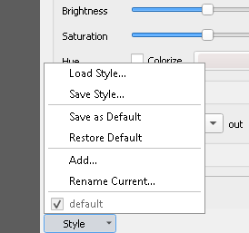

Step 6) Browse clc_legend_raster.qml file, select it and click Open button. File clc_legend_raster.qml is part of CLC datasets delivery and it is stored in the ..\supporting_files\QGIS_symbology\ directory. Layer style will be changed

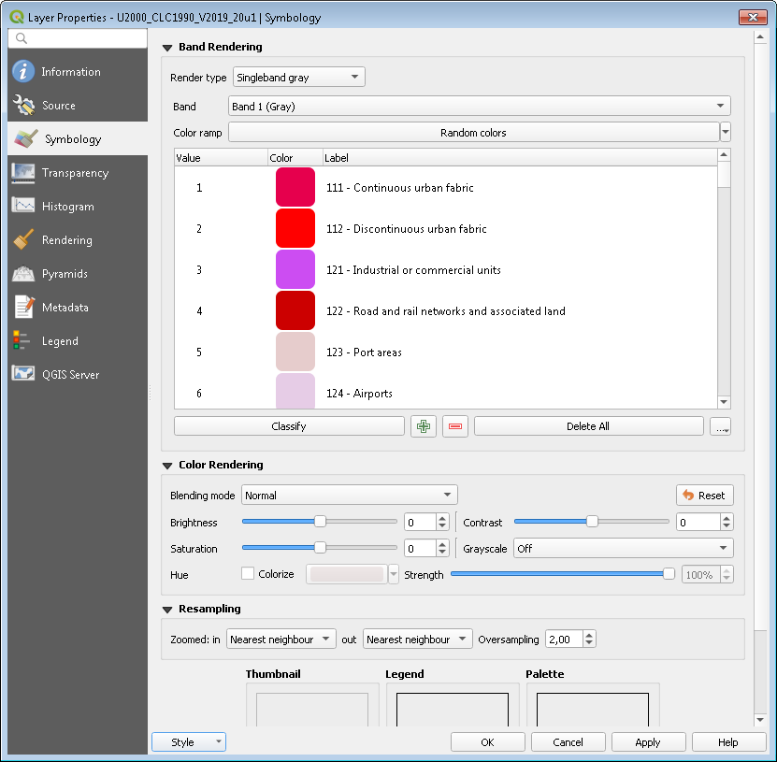

Step 7) Click Ok and layer symbology will be changed

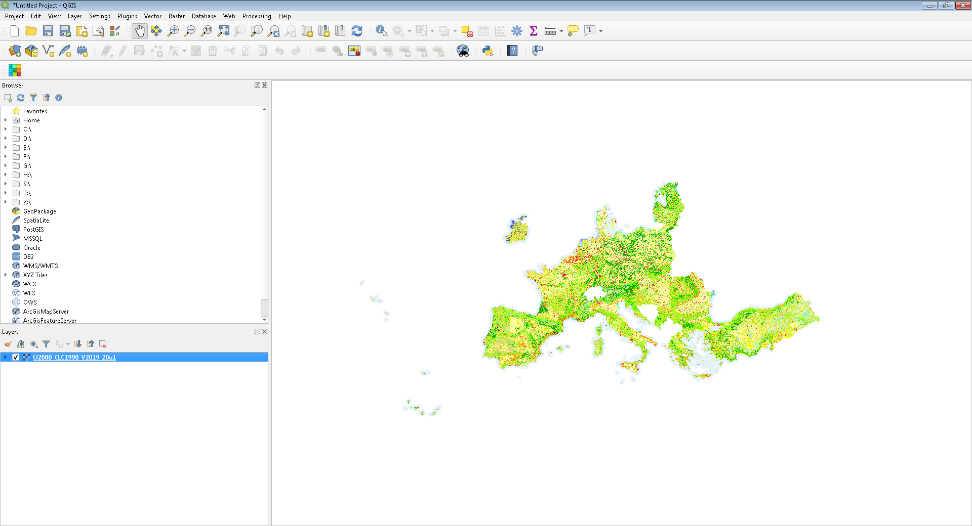

Step 8) Click to arrow left of layer name and layer legend opens
